Vaksen Gratis
Sant Dakèy

- Vaksen pou timoun ki gen 2 mwa jiska klas 12^{yèm} ane

- Pote dosye vaksen timoun nan

mÉkredi 5,12 &,19 jiyè 2023
8:00 AM - 10:00 AM Siyen (espas disponib yo limite)
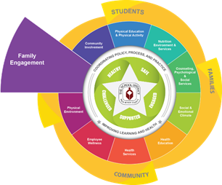
Sèvis vaksinasyon ap kòmanse a 10:00 AM

Welcome Center/Sant Dakèy
3300 Forest Hill Blvd. Building E – 50-116
West Palm Beach, FL 33406
561-434-8197
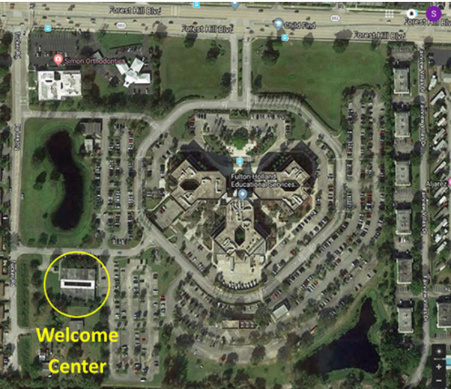

Enskripsyon Nouvo Elèv

Pote sa yo ki anba a:

- De (2) dokiman resan ki gen adrès egzat kote w rete a

- Sètifika Vaksen Florid

- Egzamen Medikal pou antre lekòl nan Eta Florid

- Dokiman pou pwouve dat nesans (batistè, paspò, rejis relijye)

Patwone pa
- The Palm Beach County Childhood Immunization Coalition

- Palm Beach County Health Department

